|  |  |
| --- | --- |
|  |  |

|  |
| --- |
| Cylindrical Gauge by MAQ Software Features Document |
|  |

# Short Description

Cylindrical Gauge by MAQ Software allows users to compare actual values against a target capacity. Each gauge in this visual represents a single metric.

# Overview

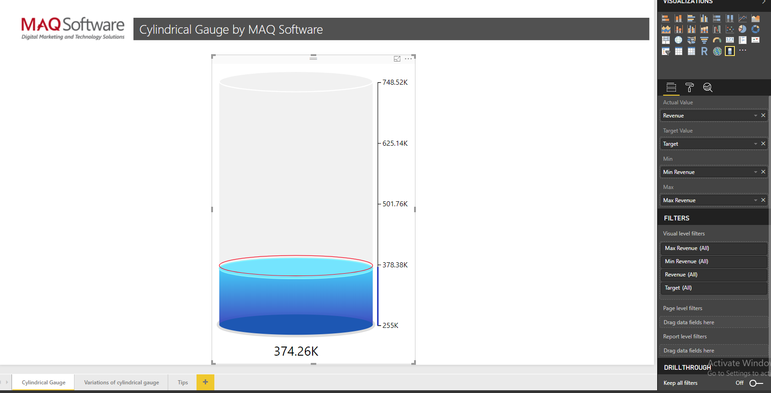

Cylindrical Gauge by MAQ Software is useful for evaluating inventory, average customer satisfaction scores, fuel, or other repository levels.

**Key features include:**

* Define the minimum and maximum values of tick marks.
* Customize the fill and border color of the cylinder.
* Navigate the visual with a vertical scrollbar when height restrictions limit visibility.
* List the value of the fill line below the cylinder for added clarity.

**Elements of Cylindrical Gauge:**

* **Configuration**: Adjust the animation, size, and color of the gauge.
* **Zone**: Toggle the “Zone” button to decide whether to include the peripherals of the filled data on the body of the gauge.
* **Data Labels**: Use data labels to indicate the unit of measurement for your shown value.

**Attributes of Cylindrical Gauge:**

* Actual Value
* Target Value
* Minimum Value
* Maximum Value

At a glance, this visual allows you to show a complete picture of your measurement data.

# Example

The CEO of a company wants to do an exact value analysis for **ACTUAL REVENUE.** To begin, they would enter “Revenue” in the ‘Actual Value’ field. Then, they follow this by entering “Target” in the ‘Target value field’, “Minimum Revenue” in the ‘Min field’, and “Maximum Revenue” in ‘Max field’. These steps result in statistical data representing the exact value of revenue.

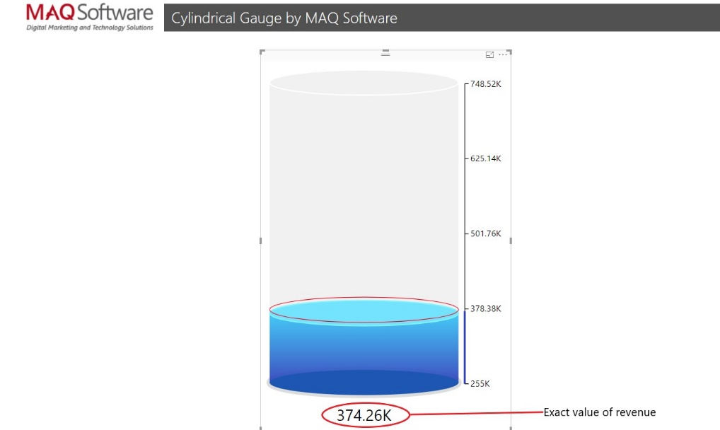

However, a deeper analysis is required to understand target revenues, minimum-maximum values, etc.

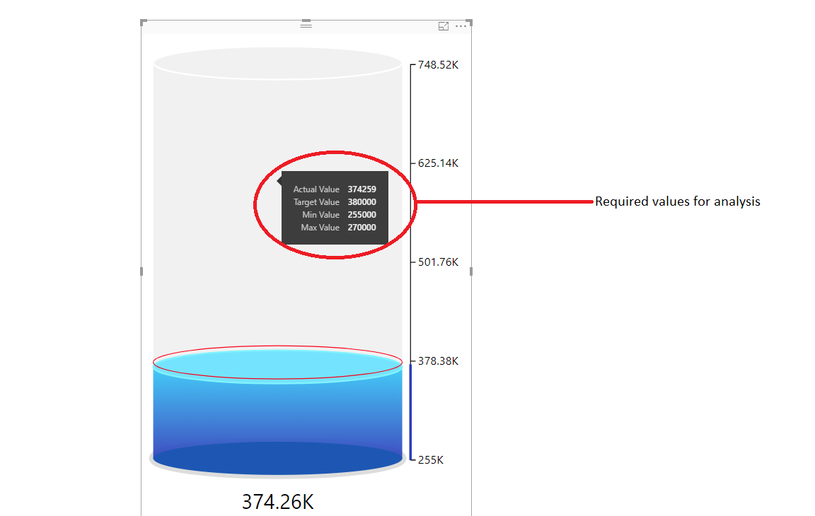

To analyze each individual value not displayed in the graph, ‘Tooltips’ can be used.

Additional features:

* **Data Labels Inside/Outside:**  Display the value of revenue inside or outside, as shown below.

**INSIDE**

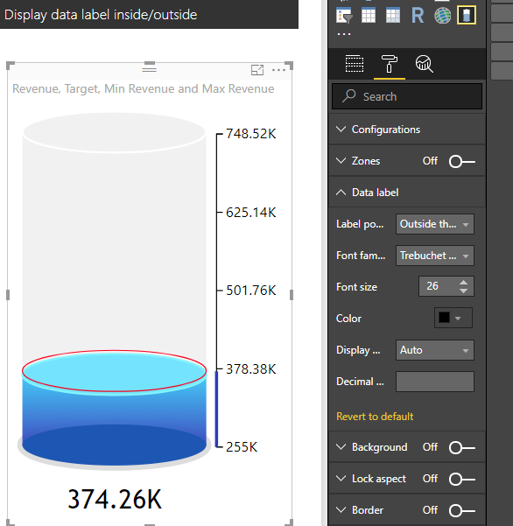

**OUTSIDE**

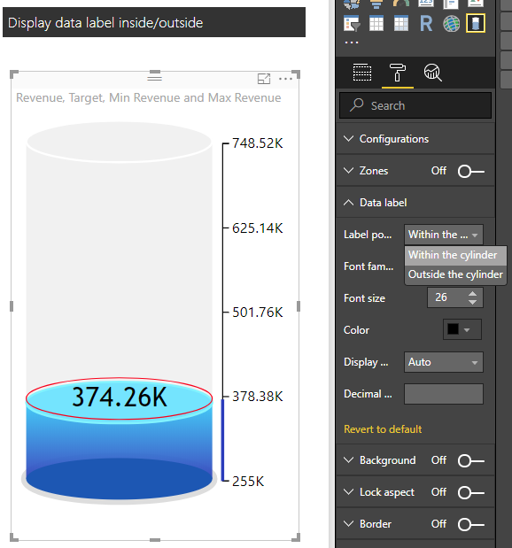

* **Display Zones**

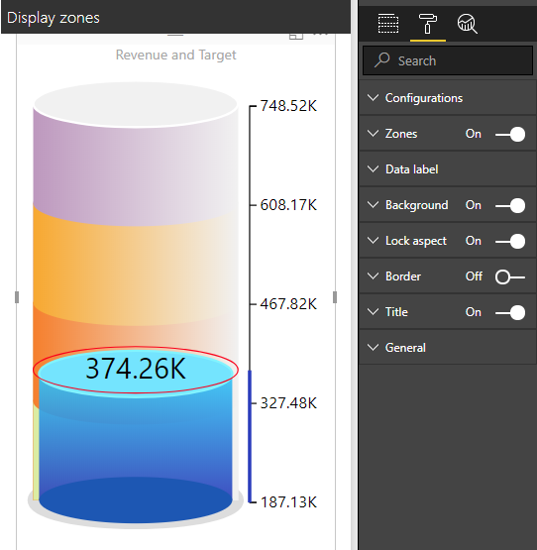

Divides the gauge into various zones and analyzes them accordingly.

* **Display Target**

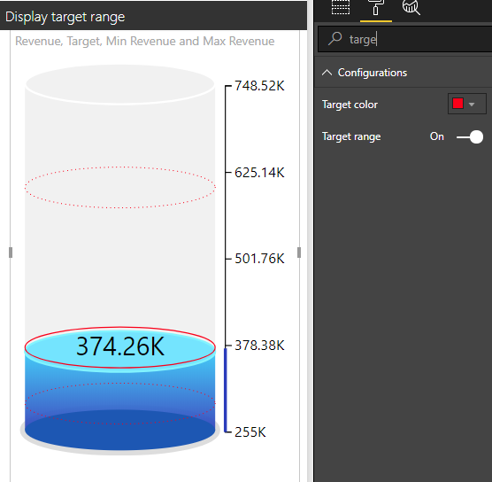

Fetches information about TARGET value.

* **Changing Animation Time**

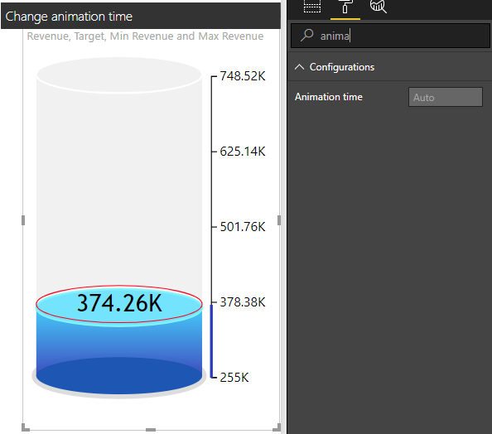

Fetches Animation time, which is presently static. The user can filter data by clicking on the bubble or on other visuals—in this case, the table visual.